Pipeline Job to build and deploy docker image

1. CI/CD Server

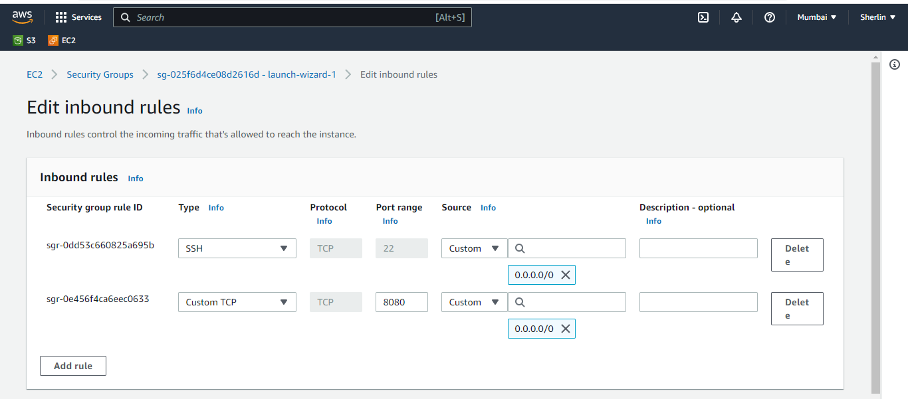

In CI/CD server

A] Update package Manager

sudo apt update

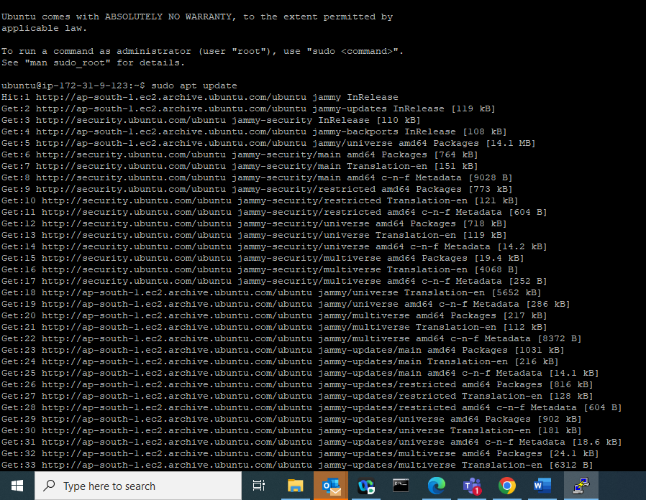

b] Install Java

sudo apt install openjdk-11-jdk -y

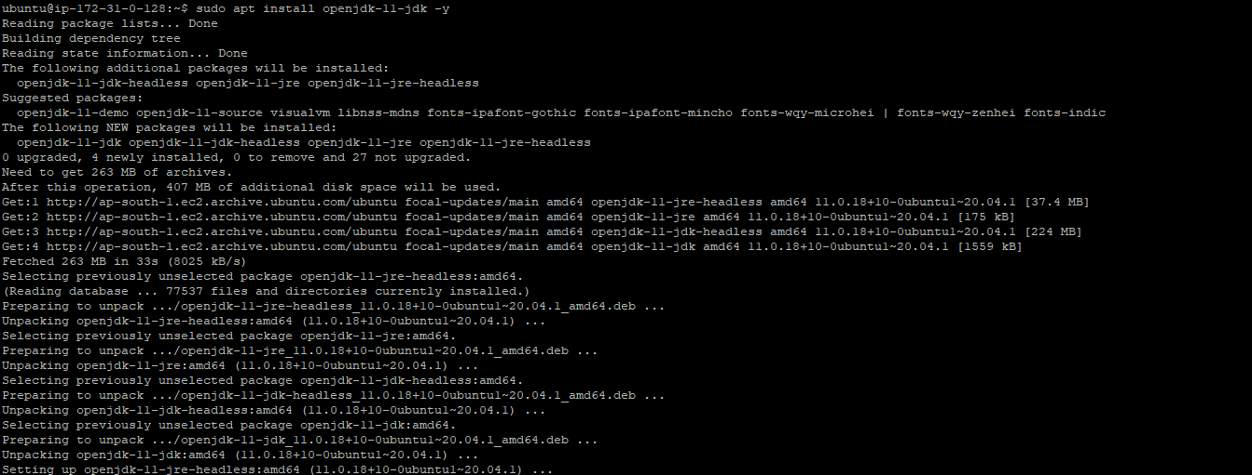

c] Install Jenkins

sudo wget -q -O – <https://pkg.jenkins.io/debian/jenkins.io.key> | sudo apt-key add –

sudo sh -c ‘echo deb [https://pkg.jenkins.io/debian-stable binary/](https://pkg.jenkins.io/debian-stable%20binary/) > /etc/apt/sources.list.d/Jenkins.list’

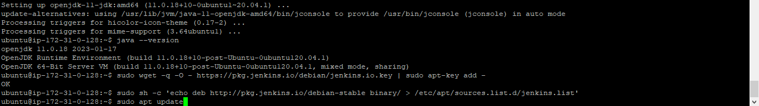

sudo apt update

sudo apt install Jenkins

sudo systemctl status Jenkins

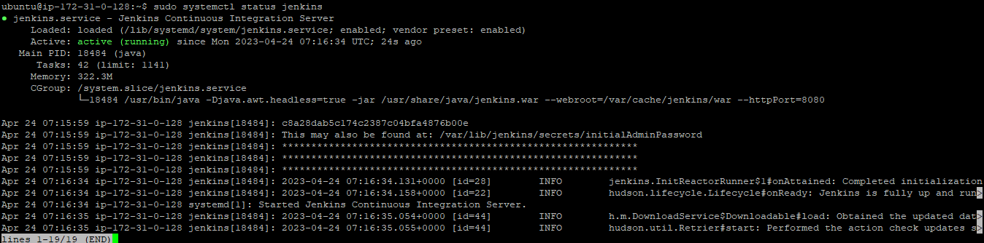

d] Install Docker

sudo apt install docker.io -y



e] Add Jenkins user to docker

sudo usermod -aG docker jenkins

f] Restart Jenkins

sudo systemctl restart jenkins



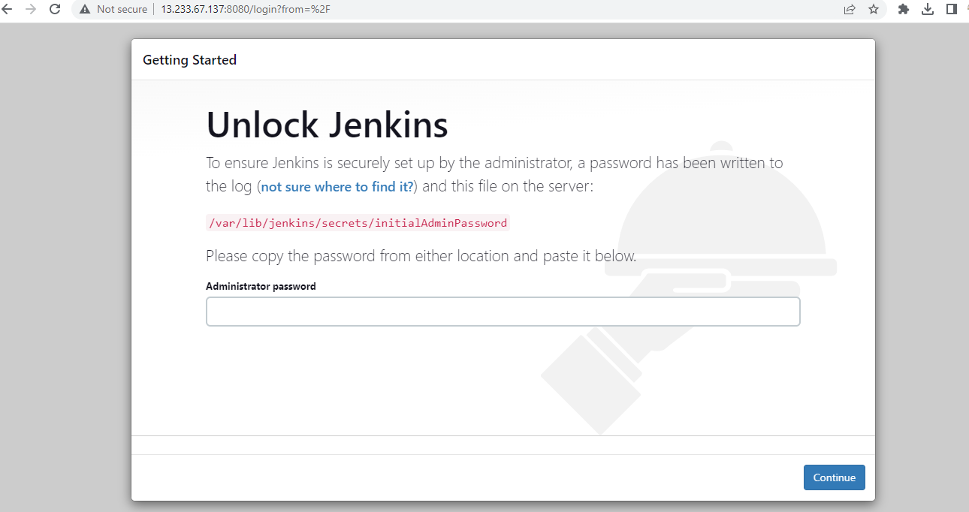

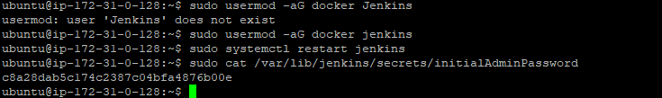

Install suggested Plugins

Github

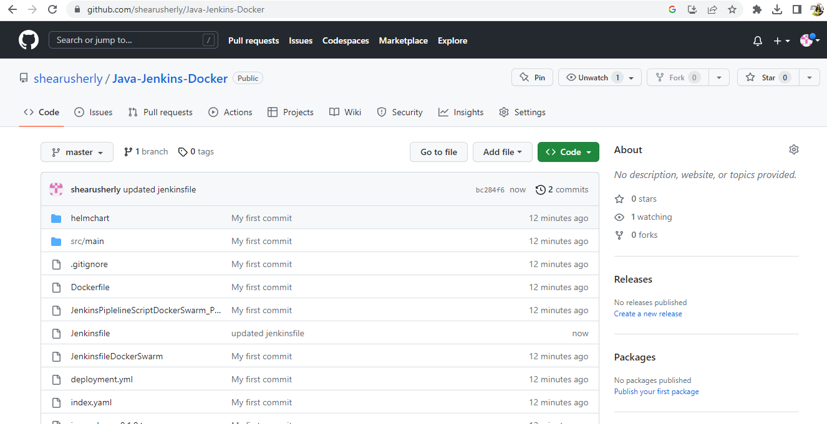

node {

//def mvnHome

stage('Git Clone') { // for display purposes

// Get some code from a GitHub repository

git url: 'https://github.com/shearusherly/Java-Jenkins-Docker.git', branch: 'master'

}

stage('Maven CLean Package') {

// Run the maven build

def mavenHome= tool name: "Maven", type: "maven"

sh "${mavenHome}/bin/mvn clean package"

}

}

node {

//def buildNumber = BUILD_NUMBER

stage('Git Clone') { // for display purposes

// Get some code from a GitHub repository

git url: 'https://github.com/shearusherly/Java-Jenkins-Docker.git', branch: 'master'

}

stage('Maven CLean Package') {

// Run the maven build

def mavenHome= tool name: "Maven", type: "maven"

sh "${mavenHome}/bin/mvn clean package"

}

stage('Build Docker Image'){

sh 'docker build -t sherlinsharmi97/java-web-app-docker-demo .'

}

}

node {

//def buildNumber = BUILD_NUMBER

stage('Git Clone') { // for display purposes

// Get some code from a GitHub repository

git url: 'https://github.com/shearusherly/Java-Jenkins-Docker.git', branch: 'master'

}

stage('Maven CLean Package') {

// Run the maven build

def mavenHome= tool name: "Maven", type: "maven"

sh "${mavenHome}/bin/mvn clean package"

}

stage('Build Docker Image'){

sh 'docker build -t sherlinsharmi97/java-web-app-docker-demo .'

}

stage('Docker Login and Push Docker Image'){

withCredentials([string(credentialsId: 'DockerHubPwd', variable: 'DockerHubPwd')]) {

sh "docker login -u sherlinsharmi97 -p ${DockerHubPwd}"

}

sh 'docker push sherlinsharmi97/java-web-app-docker-demo'

}

}

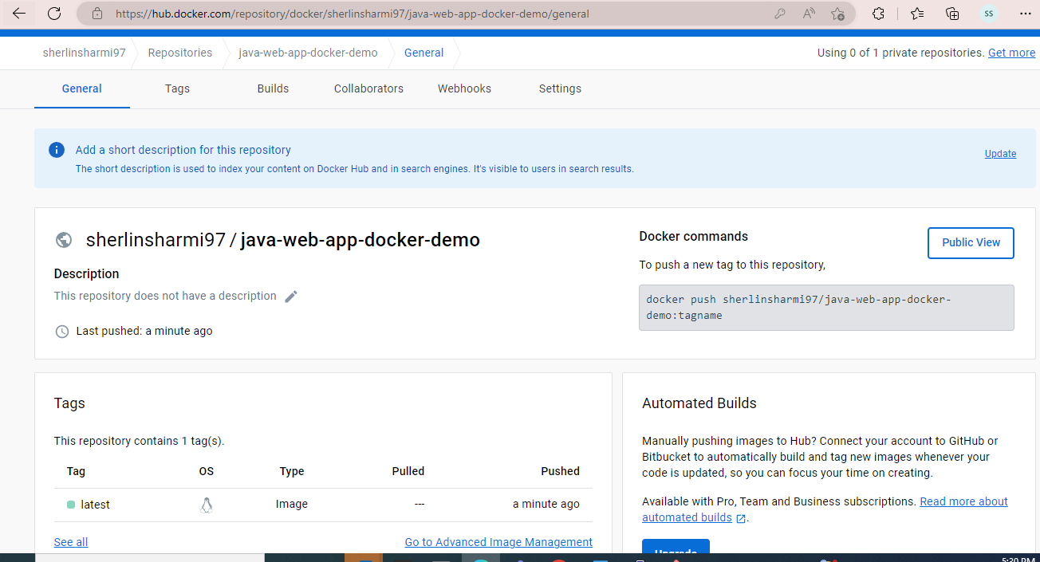

node {

//def buildNumber = BUILD_NUMBER

stage('Git Clone') { // for display purposes

// Get some code from a GitHub repository

git url: 'https://github.com/shearusherly/Java-Jenkins-Docker.git', branch: 'master'

}

stage('Maven CLean Package') {

// Run the maven build

def mavenHome= tool name: "Maven", type: "maven"

sh "${mavenHome}/bin/mvn clean package"

}

stage('Build Docker Image'){

sh 'docker build -t sherlinsharmi97/java-web-app-docker-demo .'

}

stage('Docker Login and Push Docker Image'){

withCredentials([string(credentialsId: 'DockerHubPwd', variable: 'DockerHubPwd')]) {

sh "docker login -u sherlinsharmi97 -p ${DockerHubPwd}"

}

sh 'docker push sherlinsharmi97/java-web-app-docker-demo'

}

stage('Deploy Application as Docker Container in docker deployment server'){

sshagent(['Docker_Dev_Server_SSH_U']) {

sh 'ssh -o StrictHostKeyChecking=no ubuntu@172.31.14.121 docker rm -f javawebappcontainer || true'

sh "ssh -o StrictHostKeyChecking=no ubuntu@172.31.14.121 docker run -d -p 8080:8080 --name javawebappcontainer sherlinsharmi97/java-web-app-docker-demo"

}

}

}

1. Deployment server

A] Update Package Manager

sudo apt update

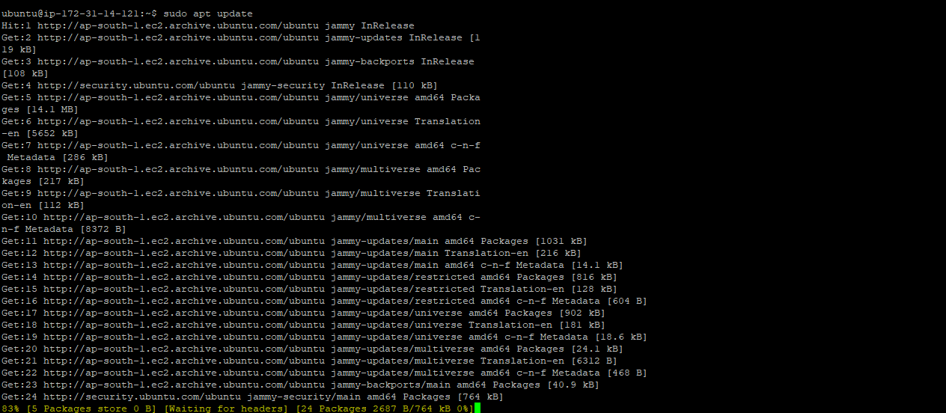

B] Install docker

sudo apt install docker.io -y

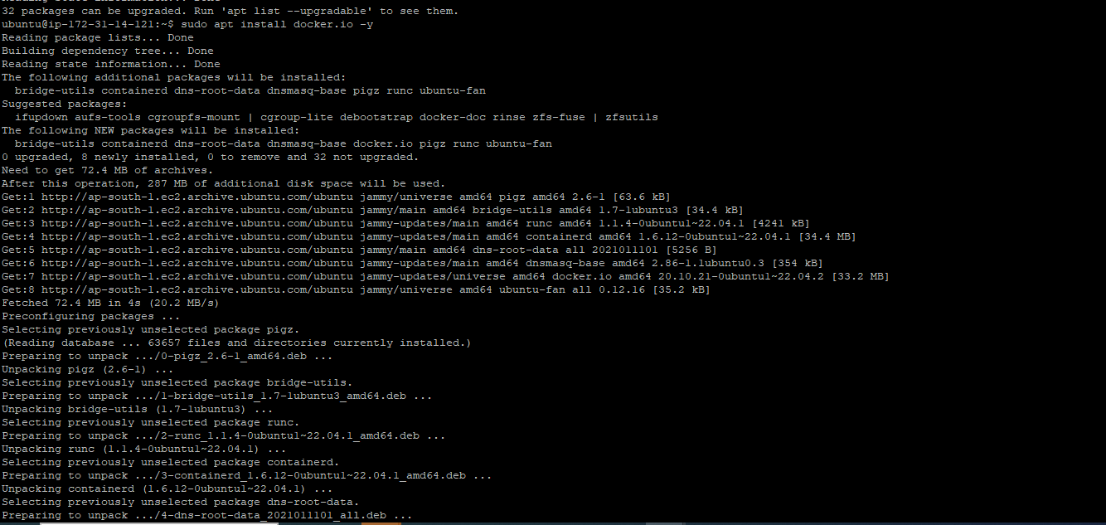

C] Add ubuntu user to docker

sudo usermod -aG docker ubuntu



D] docker info

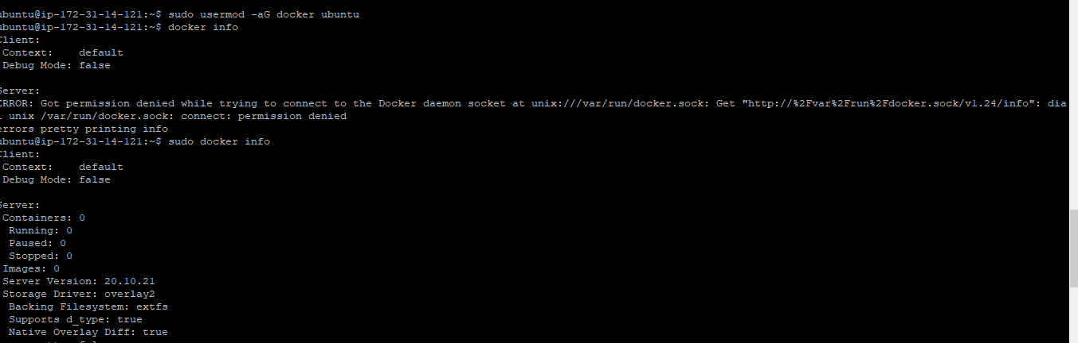

After Commit

Push Docker image to ECR

node {

//def buildNumber = BUILD_NUMBER

stage('Git Clone') { // for display purposes

// Get some code from a GitHub repository

git url: 'https://github.com/shearusherly/Java-Jenkins-Docker.git', branch: 'master'

}

stage('Maven CLean Package') {

// Run the maven build

def mavenHome= tool name: "Maven", type: "maven"

sh "${mavenHome}/bin/mvn clean package"

}

stage('Maven Test')

{

def mvnHome= tool name: "Maven", type: "maven"

sh "${mvnHome}/bin/mvn test"

}

stage('Build Docker Image'){

sh 'docker build -t sherlinsharmi97/java_web_app_docker_demo .'

}

stage('Docker Login and Push Docker Image'){

withCredentials([string(credentialsId: 'DockerHubPwd', variable: 'DockerHubPwd')]) {

sh "docker login -u sherlinsharmi97 -p ${DockerHubPwd}"

}

sh 'docker push sherlinsharmi97/java_web_app_docker_demo'

}

stage('Pushing to ECR') {

sh 'aws ecr get-login-password --region ap-south-1 | docker login --username AWS --password-stdin 487838928633.dkr.ecr.ap-south-1.amazonaws.com'

sh 'docker build -t java_web_app_docker_demo .'

sh 'docker tag java_web_app_docker_demo:latest 487838928633.dkr.ecr.ap-south-1.amazonaws.com/java_web_app_docker_demo:latest'

sh 'docker push 487838928633.dkr.ecr.ap-south-1.amazonaws.com/java_web_app_docker_demo:latest'

}

stage('Deploy Application as Docker Container in docker deployment server'){

sshagent(['Docker_Dev_Server_SSH_U']) {

sh 'ssh -o StrictHostKeyChecking=no ubuntu@172.31.39.131 docker rm -f javawebappcontainer || true'

sh "ssh -o StrictHostKeyChecking=no ubuntu@172.31.39.131 docker run -d -p 8080:8080 --name javawebappcontainer sherlinsharmi97/java_web_app_docker_demo"

}

}

}



